**1)  
USE sql_store;**

**SELECT \***

**FROM customers**

**WHERE CUSTOMER_ID=1**

**order by first_name;**

**2)  
SELECT last_name, first_name, points, (points + 10)*100**

**FROM CUSTOMERS;**

**Task1  
Select last_name, first_name, points, (points+ 10) * 100    as discount_factor from customers;**

**Task 2**

**ALTER TABLE products**

**ADD COLUMN newprice DECIMAL(10, 2);**

**UPDATE products SET newprice = unit_price * 1.1;**

**Task3)**

**select * from customers**

**where birth_date>'1990-01-01';**

**Task4)**

**select max(quantity_in_stock) from products;**

**Task5)**

**select max(unit_price) from products;**

**Task6)**

**select first_name,last_name,address,birth_date from customers**

**order by birth_date asc limit 1;**

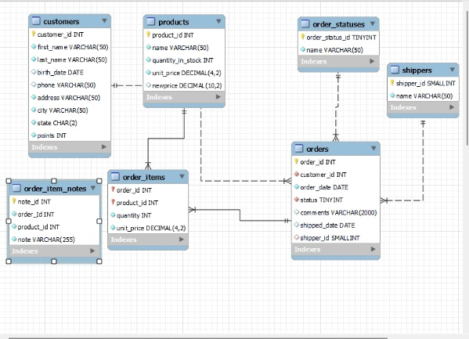

Primary key:

Table customers field customer_id

Table products field product_id

Table order_statuses field order_status_id

Table shippers field shipper_id

Table orders field order_id

Foreign key products to customers is one to one

Foreign key products to orders is one to many

Foreign key products to order_items is one to many

Foreign key shippers to orders is one to many

Foreign key orderss to order_items is one to many